**Game Rules**

4-6 players

**Set-up:**

You will need:

* 2 liar counters and enough truth counters to make up the number of players (e.g. 6 players will need 2 liar tokens and 4 truth tokens)
* 2 voting tokens each
* A number card placed in front of each player

Place the betting board and the question cards in the middle, separated into categories

**Gameplay:**

* At the start of each round, players take it in turns to take a liar/truth counter out of the bag
* Keep this hidden from the other players
* Players take turns to choose a question each round, they must take a card from the top of any category pile and place it in the centre for all players to see
* Players must all answer the question, if you have a liar counter (red) you must lie that round, if you have a truth counter (green) you must give a truthful answer to the question
* After all answers have been given, players can discuss answers and question other players
* Players must vote for who they think is lying by placing their tokens on the betting board in the centre
* Players can vote at any time during the round, they do not have to wait until all answers have been given

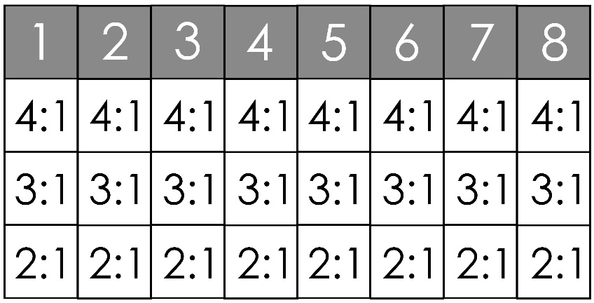

* You can bet tokens on as many players as you like and can place up to two tokens on a single player
* To vote, place your tokens under the number corresponding to the number in front of the player(s) you want to vote for
* If you are the first person to bet on a player, place your tokens in the first slot under their number, if you are the second person to bet on a player, place your tokens in the ‘3:1’ slot below their number and if you are third or later, place your tokens in the ‘2:1’ box.

Scoring:

* The box you place your tokens in corresponds to the amount of tokens you will gain for guessing correctly:
* If your tokens are in the 4:1 box, you will gain 4x the amount of tokens you placed on a player for a correct guess, if your tokens are in the 3:1 box, you will receive 3x the amount of tokens you placed and if your tokens are in the 2:1 box, you will gain 2x the amount you placed
* If you were a liar that round, you gain one token for each player who didn’t vote for you as the liar
* If you place tokens on a player who was telling the truth, you will lose all tokens placed on this player
* You will always keep 2 tokens, you can never run out of tokens

The game ends when each player has had a turn to choose a question card, the player with the most tokens at the end of the game wins.